Mrinal Bhatt

ISMG 6220

Blazin’ Burger project

Table of Contents

Executive Summary 2

Dashboards 3

Cause of Mix Results 4

Data Wrangling Script 7

Strengths/Weakness of Micro Strategy BI Tools 7

Recommendations 8

# **Executive Summary**

This report was commissioned to examine why there has been mixed financial reports for Blazin’ Burger over the past one year and to recommend ways of improving the financial status. Blazin’ Burger is burger joint that serves fresh and tasty burgers. Strategically located in Upper West Side, Lower Manhattan and Brooklyn, Blazin’ Burger is becoming the major hotspot attraction for many people.

The research draws attention to the fact that Lower Manhattan has been performing very bad, which lead to this mix financial result. If we go over the screenshots provided we would notice that Upper West Side has been performing the best. Looking over its average revenue, we notice that over the weekends it would always increase and the same could be said with the Brooklyn branch. Over the week with the increase in the average order count the revenue would increase. But when it comes to the Lower Manhattan branch the average order count would decrease during the weekends which is where most of the branches are making profit, plus being the peak time when people come out to enjoy, something like this did have a harmful effect since it resulted in low revenue. The information provided shows overall decrease in the average order count when moving towards Lower Manhattan, which decreased the average revenue. We can conclude this by looking at the trend line also, from straight upward flow in Brooklyn to a direct downward flow in Lower Manhattan with the decrease in item count.

Further investigating the NYC Health Inspections, we notice the same thing, Lower Manhattan dropping its average revenue due to the increase in the average score. If we go through the screenshots provided, we notice that in the first one only Lower Manhattan is selected, which tells us that Boro 5 is the most common one with overtime increase in the average score. Eventually crossing the constant line at 28, leading to the dip in the revenue. Moving on to the second, Upper West Side mainly consisting of Boro 2 and 1 with many small average scores. Not only did it consist of many average scores but eventually lead to the increase in revenue. And lastly, Brooklyn consisting of many Boro from 4,3,1 to 0. A mix of average scores, telling us that it never crossed the constant line 28, and remained consistent with-it revenues. Here looking at all three screenshots we notice that bigger the bubble more the average score, Boro 5 being not a good option if your surrounding restaurants receive that. And these inspection results had effect on the three locations of the branch. Lower Manhattan being hit the most.

It can be concluded that the recommendations provided could revive the bad financial status that Blazin’ Burger is going through. Those would be the ideal solutions to the problems and would increase the revenue in no time.

# **Dashboards**

# **Cause of Mix Results**

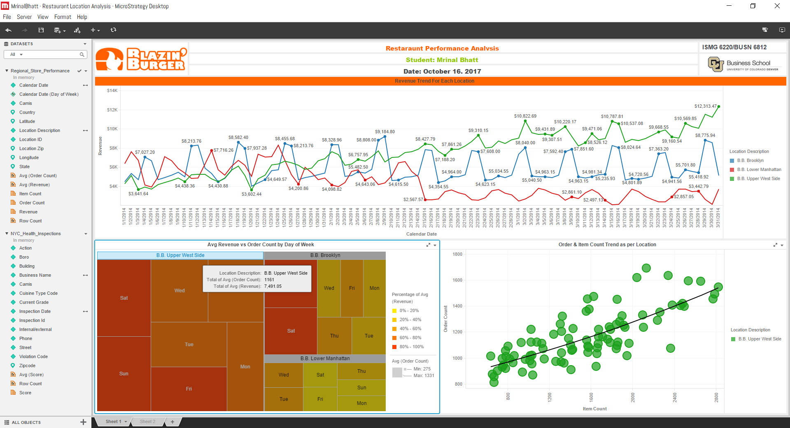***Reason 1: Order Count Decline***

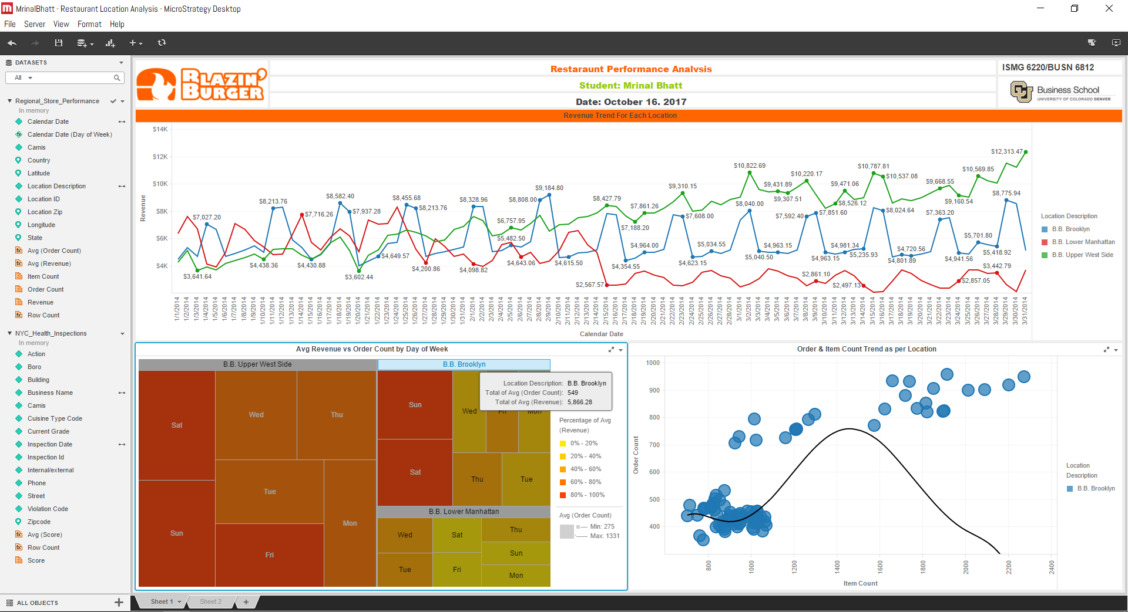

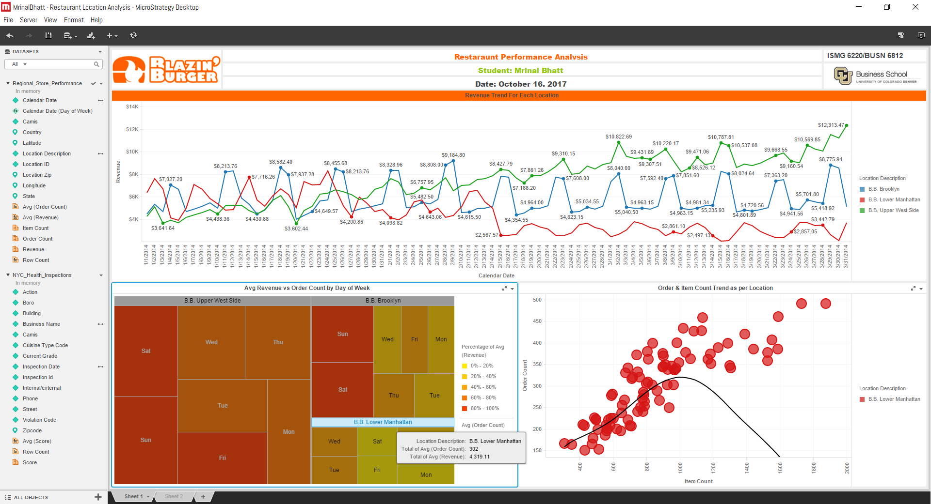

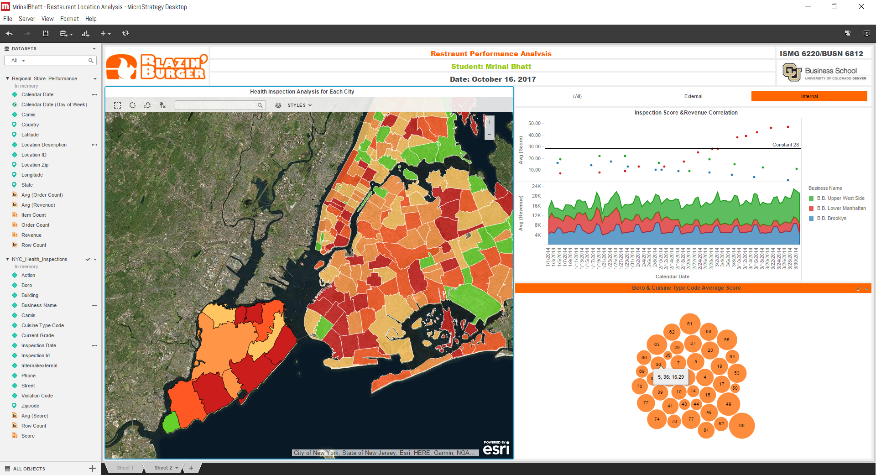***Reason 2: Increase Average Score***

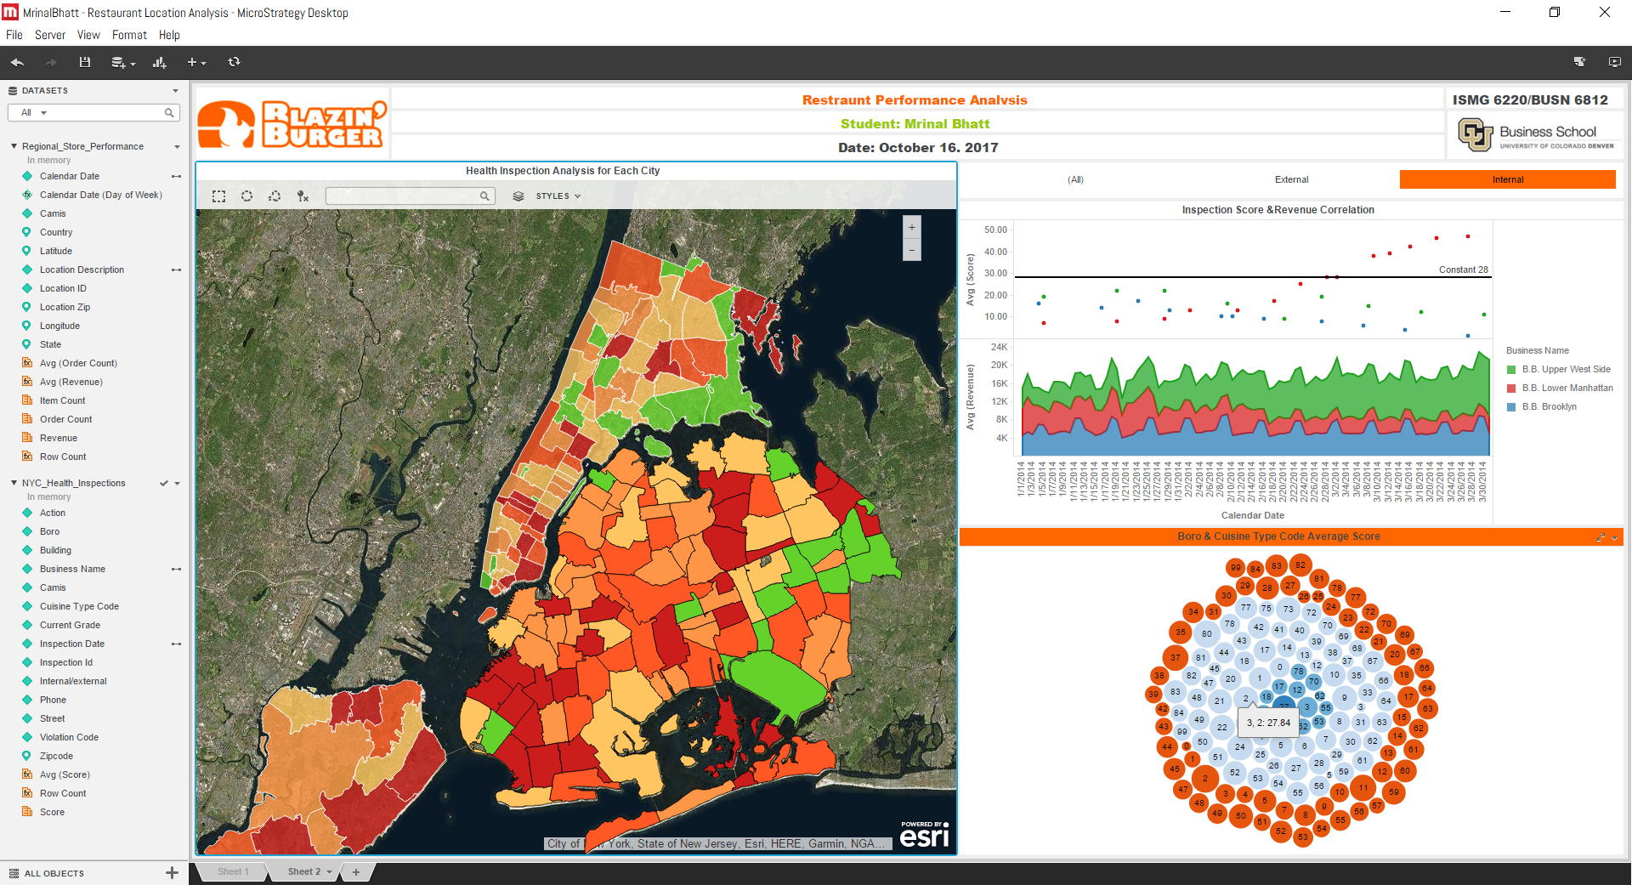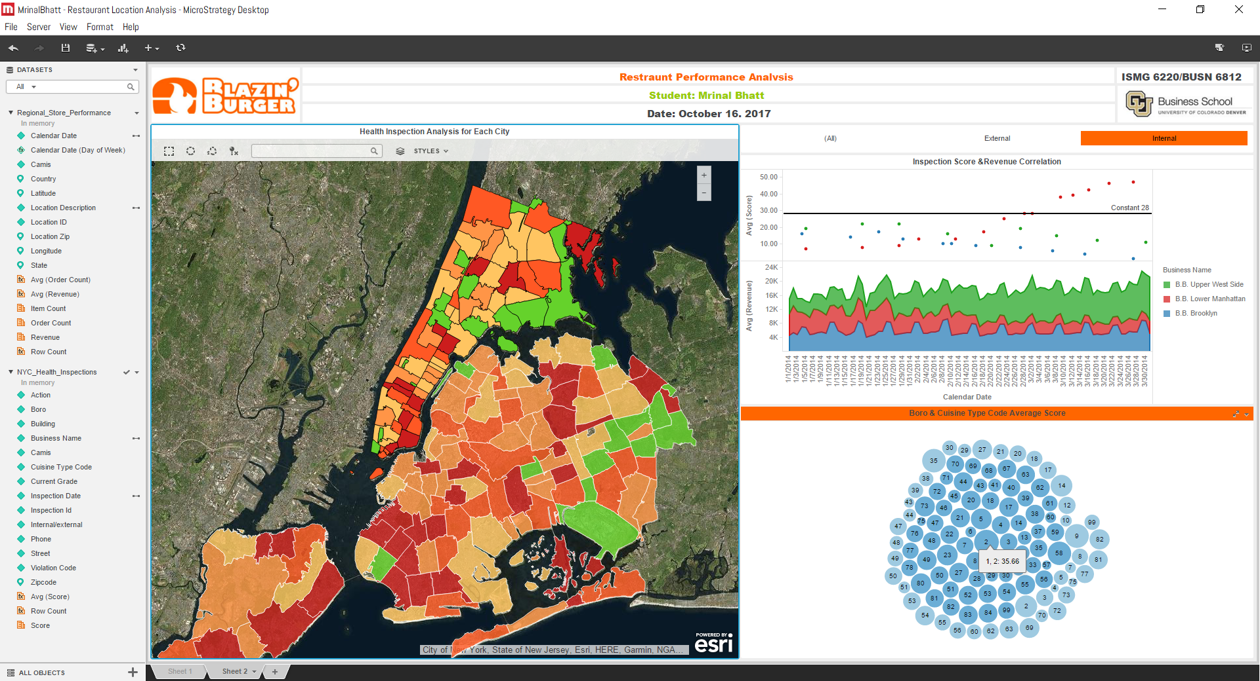

# **Data Wrangling Script**

# **Strengths/Weakness of Micro Strategy BI Tools**

**BI tool is a decision support software**which helps organizations capture, organize and analyze organizational data to make better decisions. The data could include internal data from company departments and data from external sources, such as marketing data services, social media channels or even macroeconomic information. The software provides essential insights to help businesses grow by giving information they need about product, sales, and customer behavior.

Going through the process of making the dashboard and finding the problems that are present in the organization, you realize how easy to use and helpful it would be:

|  |  |
| --- | --- |
| **Strengths** | **Weakness** |
| * Innovation in mobile BI * Product strengths * Stronger customer support * Consistency of repository-driven data handling processes | * Challenges associated with organic growth in consolidated market * Low market shares in emerging market * High learning curve for end users and developers * Lack of performance management capabilities of its own |

# **Recommendations**

Now that we know what is causing the issues, we should work towards fixing it. Firstly, trying to fix the issues regarding the dropped order count. Even though Blazin’ Burger has a website and social media outreach it seems that something is working right, and no right information is reaching the customers. Some reasons for that could be:

* Not listening to customers
* Not keeping up with the trends
* Not managing social sites properly

Some steps Blazin’ Burger can take to make sure the order count increase so that the revenue increase for Lower Manhattan:

* Evaluating online order strategy
* Focus more on millennials
* Reduce the communication gap between the employees
* Get the first-time customers to come back
* And lastly increasing the price slightly if nothing works

Now if we channel our focus towards the health inspections in the surrounding restaurants, that can be improved taking steps like:

* Training employees regularly and keeping check on those aren’t efficient, special the cooks
* Self-inspections that are performed regularly and fixing the problems
* Cleaning and maintenance schedules, frequent cleaning
* Also keeping track of when the health inspections take place

In conclusion these recommendations would help improve the overall financial situation of the campy by improving the revenue for Lower Manhattan side through improving the order count and neighboring restaurant health inspections.